EF Core 8.0 Guided Hands-On Exercises
Lab 1: Understanding ORM with a Retail Inventory System

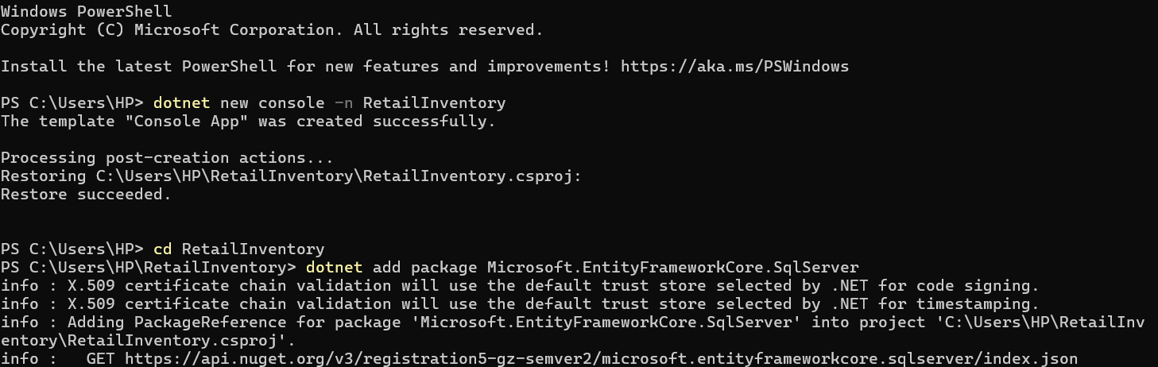
- Create a .NET Console App:

- Install EF Core Packages:
